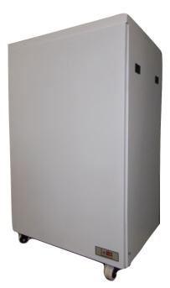This series of X-ray generators have been designed and developed for OEM application in medical field. These compact high frequency units have to be connected to an X-Ray tube to generate X-rays. The high frequency output allows for lower kV per exposure, shorter exposure and superior imaging.

**HF X-RAY GENERATOR FOR FIXED X-RAY MACHINE**

**XR15(15kW) / XR20(20kW) / XR32(kW) / XR40(40kW) / XR50(50kW)**



**Features:**

* Compact
* Lower kV per Exposure
* 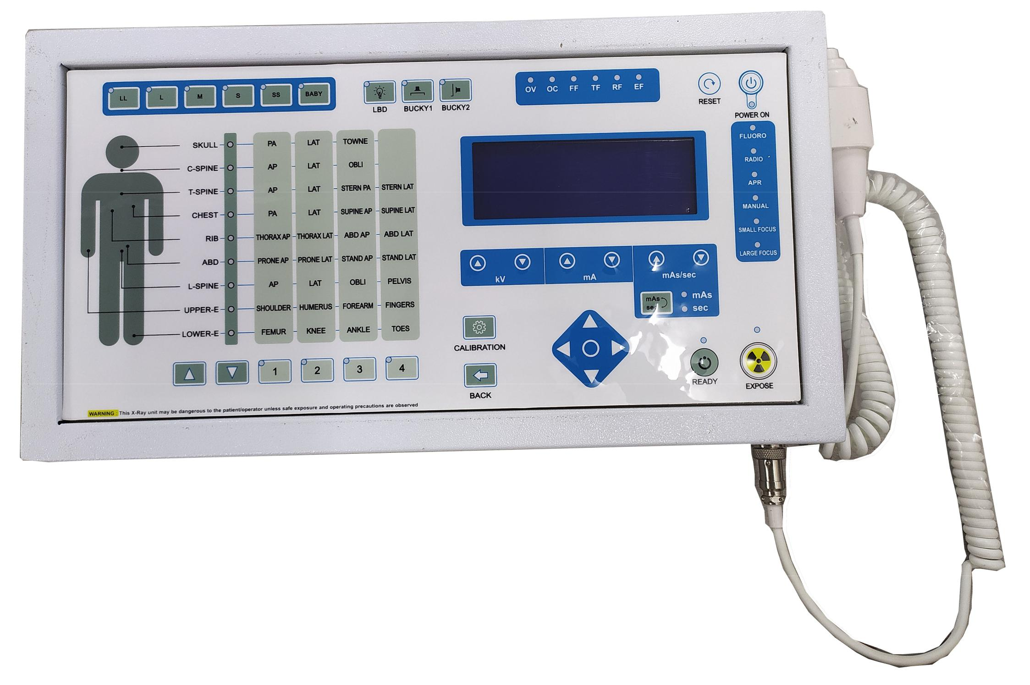Superior Imaging
* Tablet / Keyboard Control
* 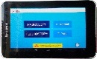Easy Serviceability
* OEM Customization Available

|  |  |  |  |  |  |
| --- | --- | --- | --- | --- | --- |
| **Technical Specifications** | | | | | |
| **PARAMETER** | SPECIFICATION | | | | |
| Input Voltage Range | 380V to 460V AC, 50Hz, 3Phase | | | | |
| Radiographic kV Range | 40kV DC to 125kV DC | | | | |
| Radiographic mA Range | 25mA to 500mA | | | | |
| Radiographic mAs Range | 0.25 to 500mAs | | | | |
| Fluoroscopic kV Range | 40kV DC to 100kV DC | | | | |
| Fluoroscopic mA Range | 0.5 to 5mA | | | | |
| Maximum Output Power | **XR15**  300mA at 50kV  150mA at 100kV 100mA at 125kV | **XR20**  400mA at 50kV  200mA at 100kV 160mA at 125kV | **XR32**  400mA at 80kV  320mA at 100kV 250mA at 125kV | **XR40**  500mA at 80kV  400mA at 100kV 320mA at 125kV | **XR50**  800mA at 50kV  500mA at 100kV 400mA at 125kV |
| Application | Radiography & Fluoroscopy (optional) | | | | |
| HF Generator Frequency | 40kHz | | | | |
| Protections | Over Voltage, Over Current, Over Temperature, Earth Fault, Filament Fault, Rotor Fault and Single Phase | | | | |
| AEC | Optional | | | | |
| Tube Compatibility | Toshiba E7239 / E7242 / (E7252 for 50kW) | | | | |
| Remote Control | Touch Screen tablet with microcontroller-based control / Keyboard | | | | |
| Housing (LxWxH) in mm | MS cabinet with nylon wheels (465 x 415 x 810; 580 x 420 x 810 for RF unit) | | | | |

For any queries or customization requests contact us at [info@ionics.co.in](mailto:info@ionics.co.in)

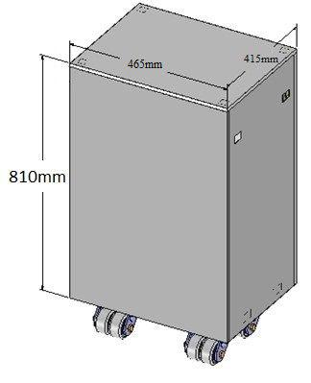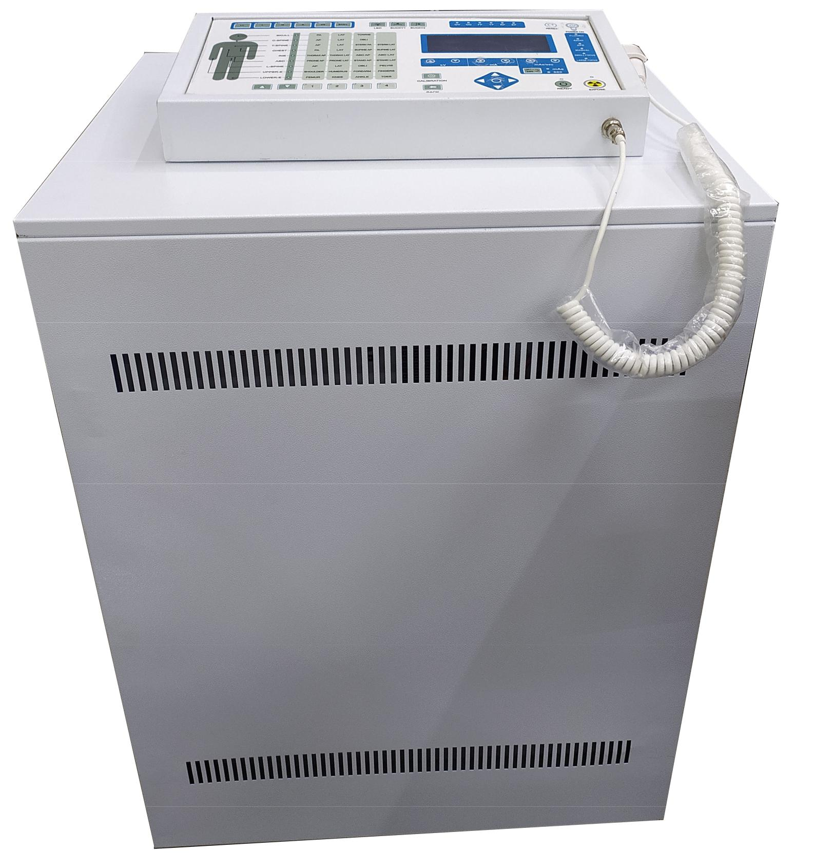For product line information visit us at [www.ionics.co.in](http://www.ionics.co.in)